DSA Lab 4
Q1

Source code
def selectionSort(array, size):

for step in range(size):
min_idx = step

for i in range(step + 1, size):
if array[i] < array[min_idx]:
min_idx = i
(array[step], array[min_idx]) = (array[min_idx], array[step])

data = [8, 6, 76, -4, 3, -5 ]
size = len(data)
selectionSort(data, size)
print('Sorted Array in Ascending Order:')
print(data)

Output
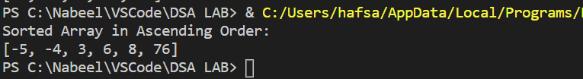

Q2

Source code
def bubble_sort(our_list):
for i in range(len(our_list)):
for j in range(len(our_list) - 1):
if our_list[j] > our_list[j+1]:

our_list[j], our_list[j+1] = our_list[j+1], our_list[j]

our_list = [8, 6, 76, -4, 3, -5 ]
bubble_sort(our_list)
print(our_list)

Output
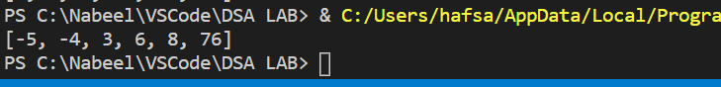

Q3

Source code
def insertion_sort(array):

for index in range(1, len(array)):
currentValue = array[index]
currentPosition = index
while currentPosition > 0 and array[currentPosition - 1] > currentValue:
array[currentPosition] = array[currentPosition -1]
currentPosition = currentPosition - 1

array[currentPosition] = currentValue

array = [8, 6, 76, -4, 3, -5 ]
insertion_sort(array)
print("sorted array: " + str(array))

Output
